Resources Share
Food Facts - How to Cut Food Waste and Maintain Food Safety (fda.gov)
Dates on food products. What do they mean? | UMN Extension
How Is Restaurant Food Waste Recycled? | How Can Restaurants Limit Food Waste? (mahoneyes.com)
BackPack Program | Feeding America
Hunger Blog Posts | Feeding America

Hunger & homelessness By state
Click a state on the map below for a snapshot of the number of people who are food insecure and experiencing homelessness.
http://www.moveforhunger.org/hunger-and-homelessness
http://www.aypf.org/blog/food-for-thought-how-food-insecurity-affects-a-childs-education
http://www.childrenshealthwatch.org/wp-content/uploads/toohungrytolearn_report.pdf
http://www.nokidhungry.org/sites/default/files/2019-10/Web%20AppendixV5.pdf
http://www.nokidhungry.org/who-we-are/hunger-facts
http://www.feedingamerica.org/hunger-in-america/child-hunger-facts
Ground-level Ozone Basics | US EPA
AirNow.gov
be_food_safe.pdf (nieonline.com)
Agriculture Technology (usda.gov)
https://hungermap.wfp.org/
They Built New Housing in East St. Louis. Now They Need People to Buy Into Their Vision (riverfronttimes.com)
Kahoot: Ending World Hunger - Details - Kahoot!.pdf
YouTube:
https://youtu.be/3QmpHJHI_aI?si=q-GDOB8a23QsaH5g
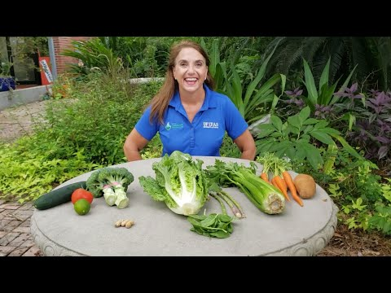
https://youtu.be/2zvGv8yVE9s
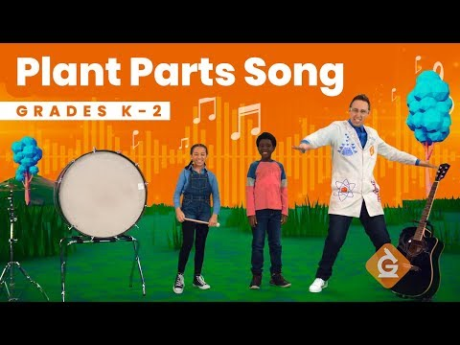

Study Jams - Food Webs (youtube.com)

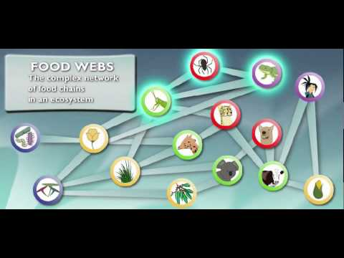
Food Chains: StudyJams! Science | Scholastic.com

Journey 2050: Check out the Game (youtube.com)

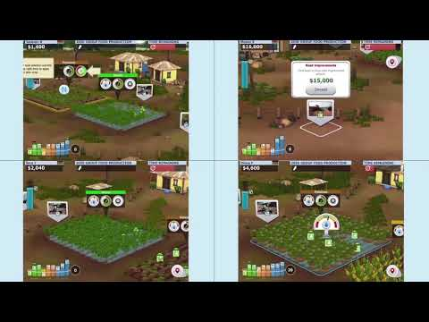
Games:
JOIN US ON A JOURNEY TO THE YEAR 2050!
Along your journey you will learn about different countries, careers and innovations that make agriculture one of the leading industries in the world.
Unlike any farming game you’ve ever played, Journey 2050 is based on real-life challenges and opportunities. If nothing changes between today and the year 2050, farmers will have to grow 60-70% more food! How do you think farmers and agribusiness can meet this challenge?
Watch the videos, play the games, learn about world food sustainability and get involved today
http://www.journey2050.com/

Lesson Plans
SDG Resources for Educators - Zero Hunger (unesco.org)
7 Great Lessons to Teach Kids about Hunger and Food Insecurity (kidworldcitizen.org)
Lessons Archive - Florida Agriculture in the Classroom (faitc.org)
Grades K-2: Plant Tops and Bottoms | National Agriculture in the Classroom (agclassroom.org)
How Did That Get in My Lunchbox? | National Agriculture in the Classroom (agclassroom.org)
A Garden Plot: The Tale of Peter Rabbit | National Agriculture in the Classroom (agclassroom.org)
Grades 3-5: My Farm Web (Grades 3-5) | National Agriculture in the Classroom (agclassroom.org)
Grades 6-8: Plant Parts and Functions | National Agriculture in the Classroom (agclassroom.org)
Grades 9-12: My Agricultural Connections (Grades 9-12) | National Agriculture in the Classroom (agclassroom.org)

Cpalms: https://www.cpalms.org/
Model Eliciting Activities

Best Vegetable Garden
Grade 3- Subject(s): Mathematics, English Language Arts
The students will plan a vegetable garden, deciding which kinds of vegetables to plant, how many plants of each kind will fit, and where each plant will be planted in a fixed-area garden design. Then they will revise their design based on new garden dimensions and additional plant options. Students will explore the concept of area to plan their garden and they will practice solving 1 and 2-step real-world problems using the four operations to develop their ideas.

What Does Your Garden Grow?
Grade 3- Subject(s): Mathematics, English Language Arts, Science
In this model eliciting activity students use data about the temperature and water requirements of plants to figure out when the plants should be planted. They also use data such as space requirements and time until harvest to make judgments about which plants would best suit the needs of students planning a school garden in Florida.

A Vegetable Garden for All Seasons
Grade 3-Subject(s): English Language Arts, Science
This MEA (Model Elicting Activity) lesson provides students with information about different vegetables. The students are given the task to rank their selections of which one vegetable the principal should plant in the school garden that will survive through all seasonal changes.

Lett'uce Begin Our Area
Grade 3- Subject(s): Mathematics, English Language Arts
In this garden of veggies, students will find the area to determine which vegetable garden beds should be created and where they should be located. Students will submit a letter to the client explaining their procedure for choosing the garden beds and layout.

Fertilizing Fun!
Grade 3- Subject(s): English Language Arts, Science
Students are selected to develop procedures for conducting a study on plant fertilizers. They are given data to determine which fertilizer is best for school gardens based on growth rate, size of vegetables, number of vegetables, taste, and color. They will reassess these fertilizers during the twist incorporating safety ratings.

Save the Plants!
Grade 5-Subject(s): English Language Arts, Science
This MEA asks the students to design a system to water plants using rainwater. Students apply their knowledge of the water cycle and grade specific content vocabulary to label and justify their design. Students also use context clues and dictionary skills to define the term permeability.

Seed Starters
Subject(s): English Language Arts, Science
This MEA presents a non-profit group that helps start schools gardens. This client is looking to switch to a tomato seed that is adapted to increased moisture in the soil due to precipitation and is versatile and great tasting. The engineering team will examine the seeds presented and develop a procedural method to rank the seeds based on the client's needs.

Raising Your Garden MEA
Grade 7- Subject(s): Mathematics, English Language Arts, Science
Raising Your Garden MEA provides students with a real-world engineering problem in which they must work as a team to design a procedure to select the best material for building raised garden beds. The focus of this MEA is to recognize the importance of choosing the correct material for building a raised garden bed, what information is needed before starting a gardening project, and to consider the environmental and economic impact the garden will have on the school.

Corn Conundrum MEA
Grade Level(s): 9, 10, 11, 12
Subject(s): Mathematics, English Language Arts, Science
The Corn Conundrum MEA provides students with an agricultural problem in which they must work as a team to develop a procedure to select the best variety of corn to grow under drier conditions predicted by models of global climate change. Students must determine the most important factors that make planting crops sustainable in restricted climate conditions for the client. The focus of this MEA is manipulating factors relating to plant biology, including transpiration and photosynthesis.

Other Resources Used in Researching this Workshop:

Kids v Global Warming - Children's Environmental Literacy Foundation (celfeducation.org)
Food waste article for students | McKinsey for Kids | McKinsey
COVID-19’s impact on food insecurity | McKinsey & Company
Lesson Plans, Teacher Guides and Online Environmental Resources for Educators: Waste and Recycling | US EPA
From PBS LearningMedia:
Kids Go Green: Reducing Food Waste
https://florida.pbslearningmedia.org/resource/ee18-sci-foodwst/kids-go-green-reducing-food-waste/?utm_source=PFacebook
Snickers commercial. You’re not you when you’re hungry
Peter Rabbit – Food
https://www.un.org/sustainabledevelopment/wp-content/uploads/2021/06/PR2-UN-Campaign-Art-Package-for-Review-5-17-21-Lo.pdf
Pack A Waste-Free Lunch | US EPA
Reducing Food Waste Activity Book | US EPA
Be A Food Waste Warrior | Educators Toolkits | WWF (worldwildlife.org)
Food Waste in America in 2024: Statistics & Facts | RTS
http://www.cec.org/flwy/
Lesson Plans, Teacher Guides and Online Environmental Resources for Educators: Waste and Recycling | US EPA
https://sustainability-innovation.asu.edu/sustainabilitysolutions/programs/teachersacademy/teacher-resources/
SDG Book Club | Archive - United Nations Sustainable Development
Lesson Plans, Teacher Guides and Online Environmental Resources for Educators: Waste and Recycling | US EPA
Teacher Resources | Rob and Melani Walton Sustainability Solutions (asu.edu)
https://www.epa.gov/students/pack-waste-free-lunch
http://www.cec.org/flwy/
Kids v Global Warming - Children's Environmental Literacy Foundation (celfeducation.org)
https://www.worldwildlife.org/stories/what-farmers-found-when-they-measured-fresh-produce-left-in-the-field#:~:text=About%2016%25%20of%20US%20food,certainly%20not%20the%20desired%20outcome.

https://ballardbrief.byu.edu/issue-briefs/food-waste-in-the-united-states#:~:text=According%20to%20the%20Environmental%20Protection,tons%20that%20went%20into%20landfills.

https://www.weforum.org/agenda/2019/04/south-korea-recycling-food-waste/#:~:text=But%20the%20South%20Korean%20government,recycling%20using%20special%20biodegradable%20bags.

https://www.usda.gov/foodwaste/faqs#:~:text=At%20the%20retail%20level%2C%20equipment,et%20al%20(2014)).

https://www.avristech.com/who-is-responsible-for-food-loss-or-food-waste/#:~:text=Here%20are%20few%20simple%20ways,manage%20food%20wastes%20in%20restaurants.&text=Households%20are%20the%20major%20contributors,occurs%20at%20the%20consumer%20stage.

https://earth.org/food-waste-in-america/#:~:text=Over%20240%20Million%20Slices%20of,every%20year%20across%20the%20country.

https://www.rts.com/resources/guides/food-waste-america/#:~:text=Grocery%20Store%20Food%20Waste,of%20profit%20from%20food%20sales.
https://www.usda.gov/media/press-releases/2021/07/30/us-government-advances-anti-hunger-climate-initiatives-food-systems#:~:text=Recognizing%20that%20school%20feeding%20programs,meals%20available%20for%20all%20children

